

SYMBIOSIS INTERNATIONAL (DEEMED UNIVERSITY)
(Established under section 3 of the UGC Act 1956)
Re-accredited by NAAC with “A” Grade

Name of the Student: Sneha Sah PRN: 25070122189
Semester: 3 Year: AY 25-29
ASSIGNMENT No: 9
TITLE: Write a Java program to demonstrate the use of the final keyword with variables, methods, and classes.

Problem Statement: Write a Java program to demonstrate the use of the final keyword with variables, methods, and classes.

Theory: The final keyword restricts modification in Java programs. A final variable cannot be reassigned after initialization. A final method cannot be overridden by subclasses, while a final class cannot be inherited. This improves security, prevents accidental modifications, and increases program reliability. Final is commonly used for constants and immutable classes.

SOURCE CODE:

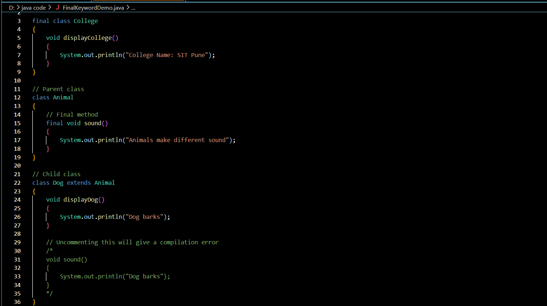
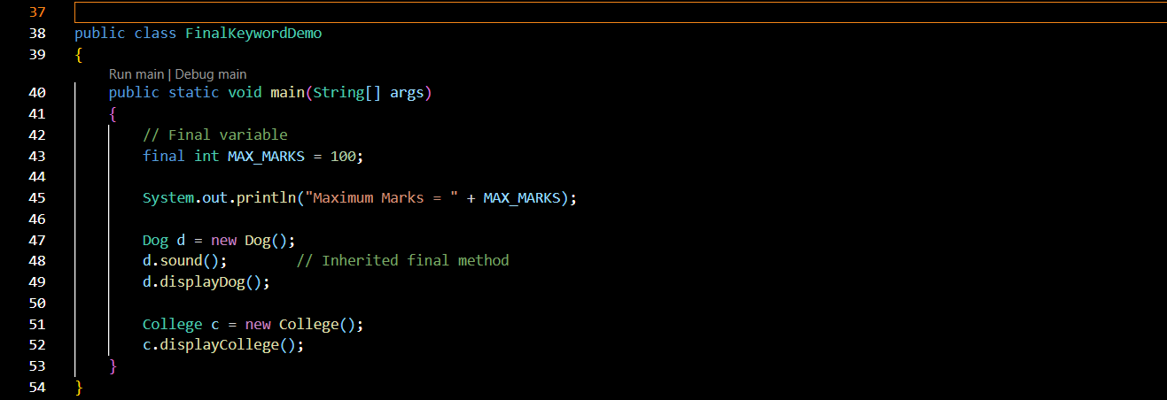

Output:

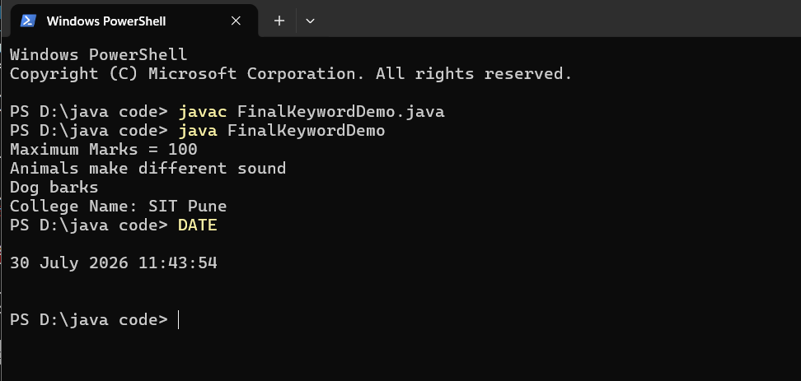

Exercise 1.
Create a Bank Account program where account number is final and cannot be changed.

Source code:
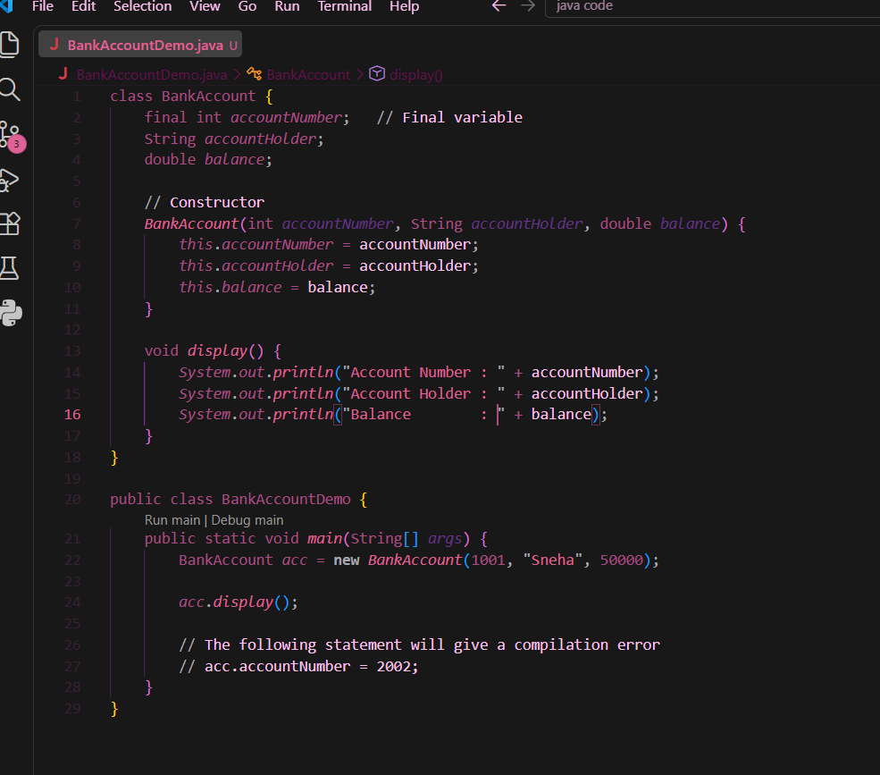

Output:

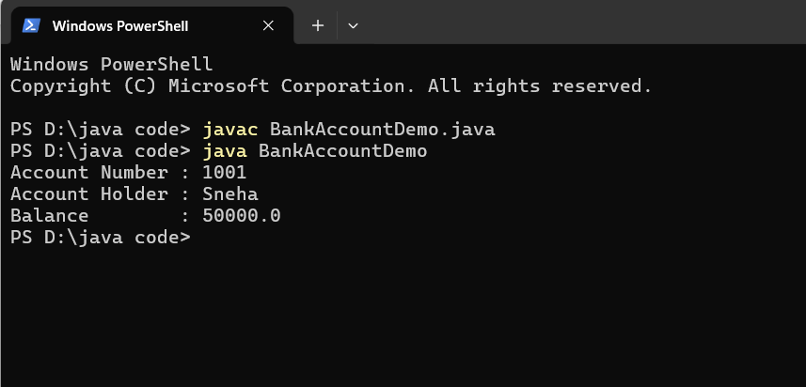
2. Create a Library Book Management program where the book ISBN is declared as final and cannot be changed once assigned. Display the book's ISBN, title, author, and price.

Source code:

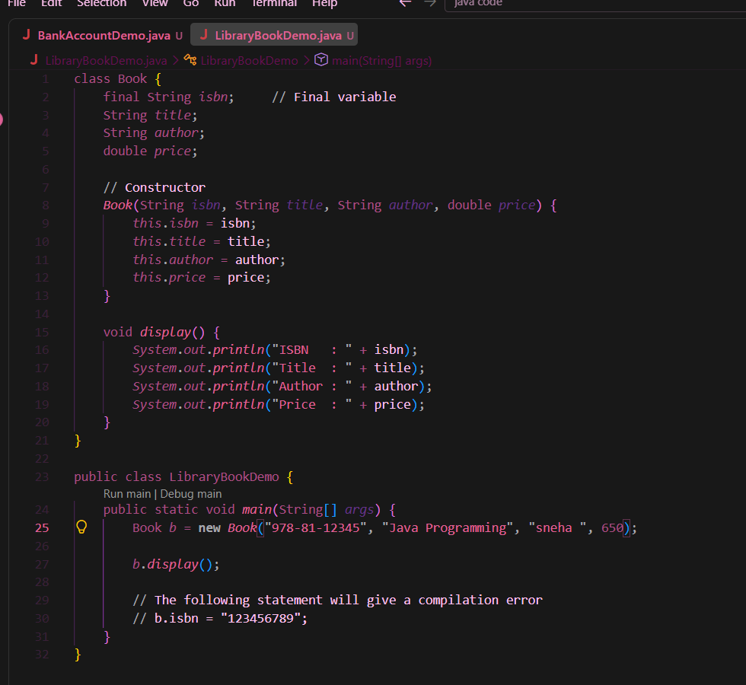

Output:

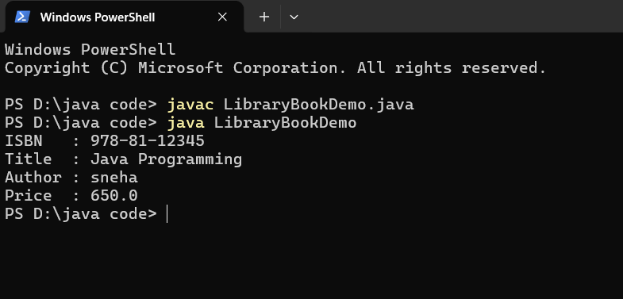
Conclusion
The final keyword in Java is used to restrict modification and improve program reliability. A final variable cannot be reassigned after initialization, a final method cannot be overridden by subclasses, and a final class cannot be inherited. In this assignment, the final keyword was successfully demonstrated using a Bank Account program (final account number) and a Library Book Management program (final ISBN). Thus, the use of the final keyword helps create secure, constant, and reliable Java programs.

